Scientific Sensor Data Manager
Class Diagram and Data Flow Diagram
Version <1.0>
Approval
The Guidance Team and the customer, shall approve this document.
Document Change Control
Initial Release: | 4/5/2013
Current Release: | 1.0
Indicator of Last Page in Document: | ∑
Date of Last Review: | 4/5/2013
Date of Next Review: | 4/12/2013
Target Date for Next Update: | 4/12/2013
Distribution List
This following list of people shall receive a copy of this document every time a new version of this document becomes available:
Guidance Team Members:
Dr. Ann Gates
Omar Ochoa
Luis Garcia
Customer: Drs. Deana Pennington and Salamah Salamah

Software Team Members:
Juan Rodriguez
Joseph Aguirre
Andre de la Cruz
Jesus Tabares
Arturo Delgado
Table of Contents
Document Control ii
Approval ii
Document Change Control ii
Distribution List ii
1. Class Diagram 4
2. Data Flow Diagram 5

Class Diagram

The class diagram below represents the different classes that the system will use. The classes in a class diagram represent both the main objects, interactions in the application, and the classes to be programmed. The upper parts of the tables hold the name of the classes, the middle parts are the attributes of the class, and the bottom parts are the methods that the class can do. The lines represent relations between the classes

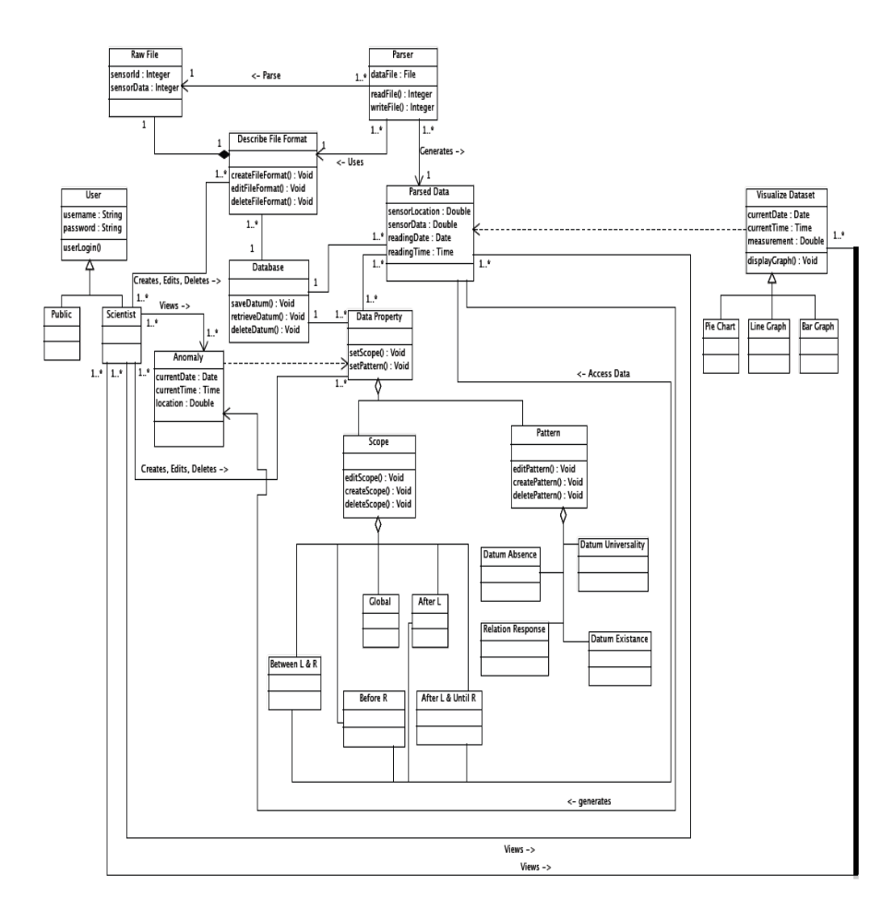
Figure 1

Data Flow Diagram

The data flow diagram below represents the flow of data through the system. The squares in the diagram represent the sources or destinations of the data. The rounded squares represent process that change or manipulate data. The arrow is the direction of the flow of data. The incomplete rectangles are the data stores of the system. Figure 2 is a level 0 or context representation of the data flow. Figure 3 is a level 1 with a closes up view of the internal flow of the data inside the system. Figure 4 is a level 2 with a more detail view of the data flow within the system.

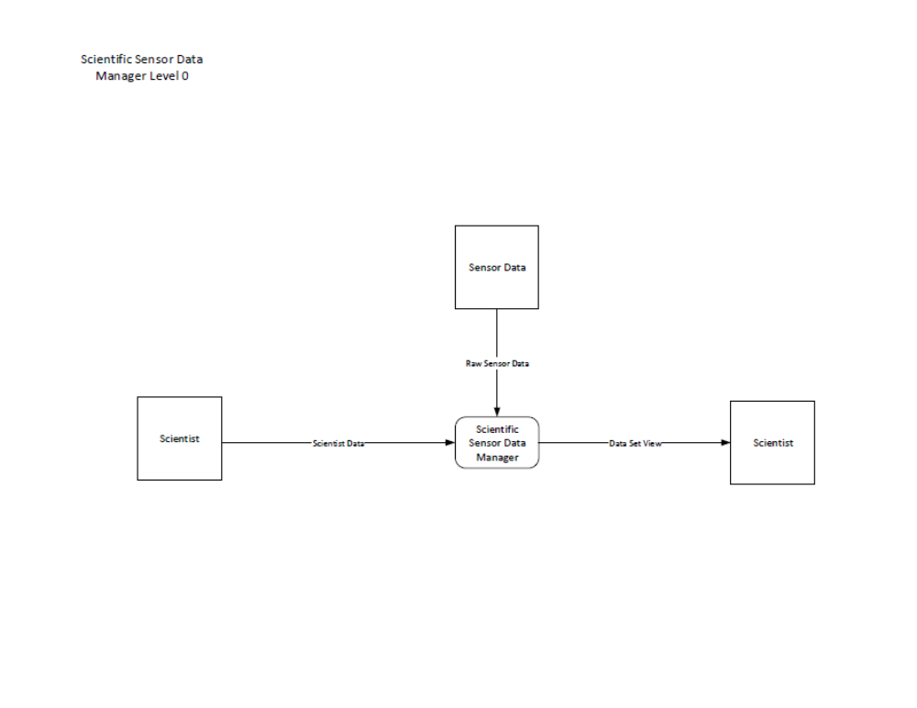
Figure 2

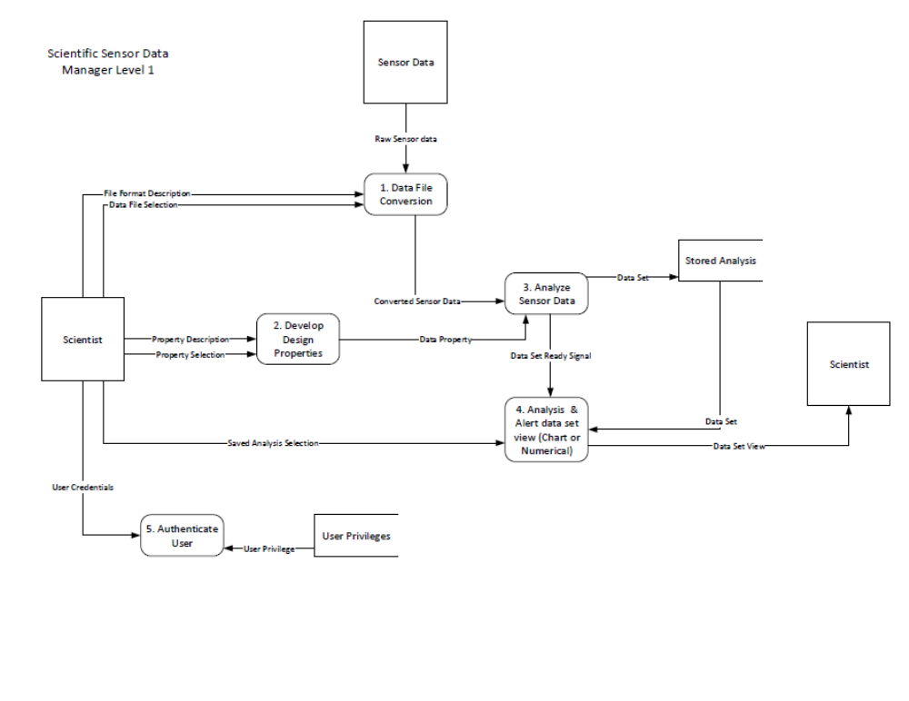
Figure 3

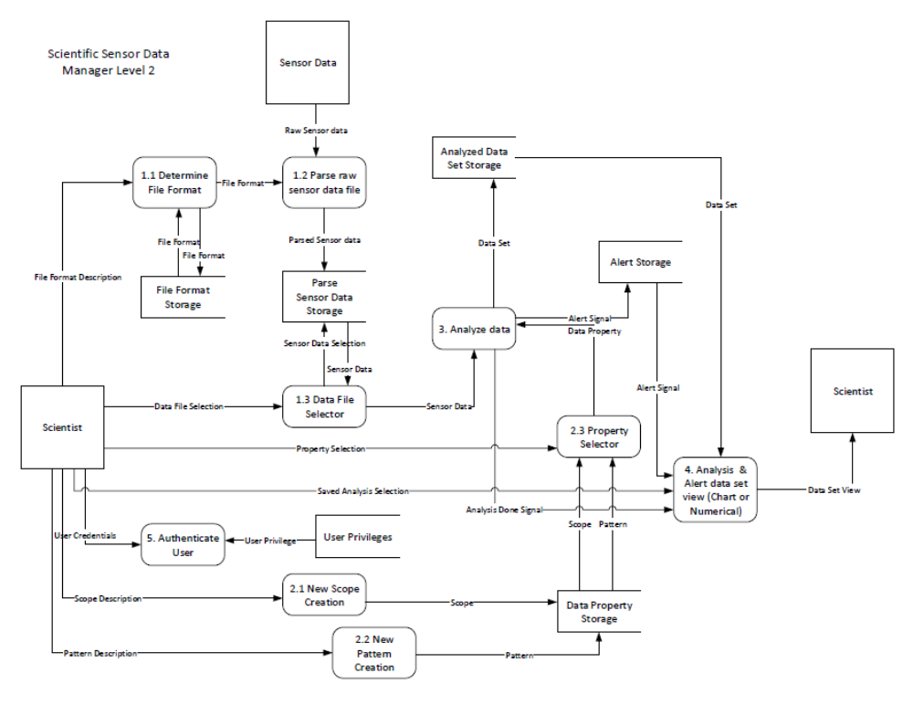
Figure 4

∑

